**New Syllabus NESA Questions:**

1) C

2) D

3) C

4)

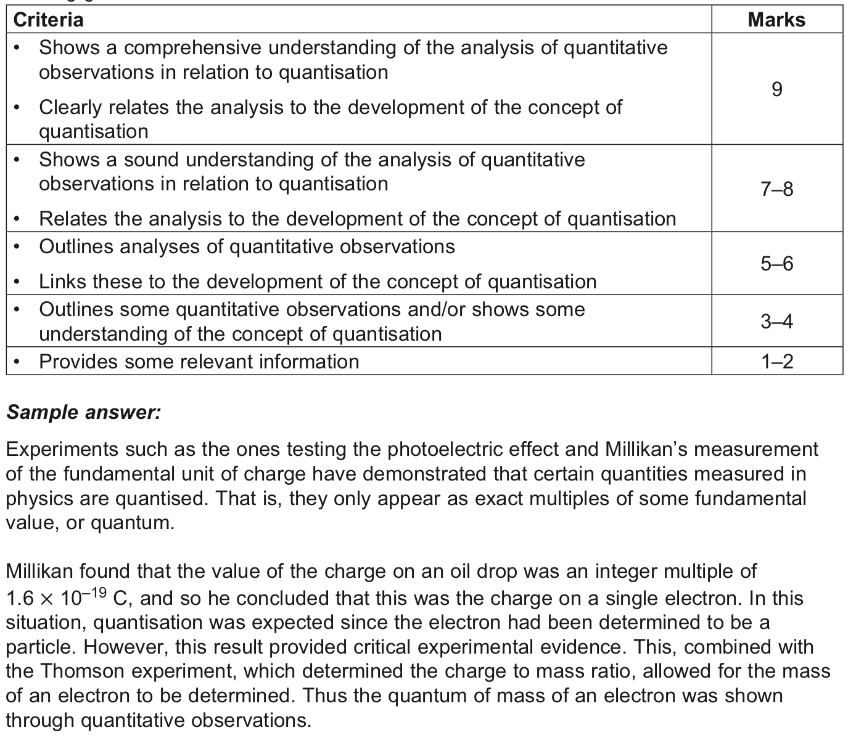

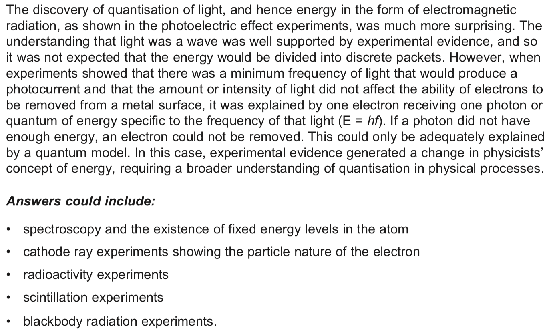

**Past HSC Questions:**

**2018:**

**34)**

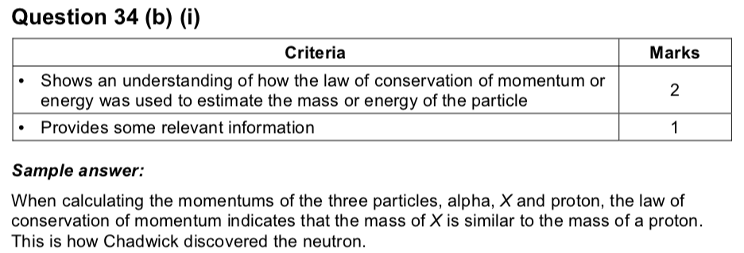

**2017:**

9) A

**2016:**

12) B

**2015:**

3) B

**2014:**

18) D

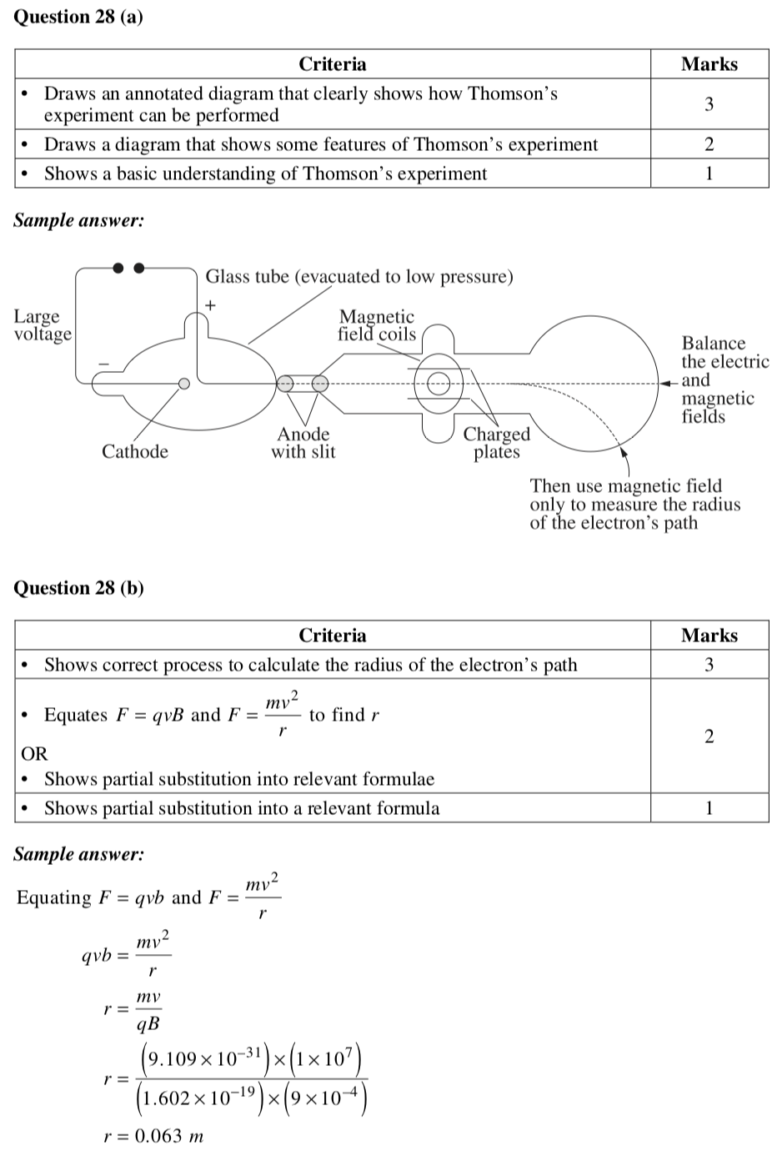



**2011:**

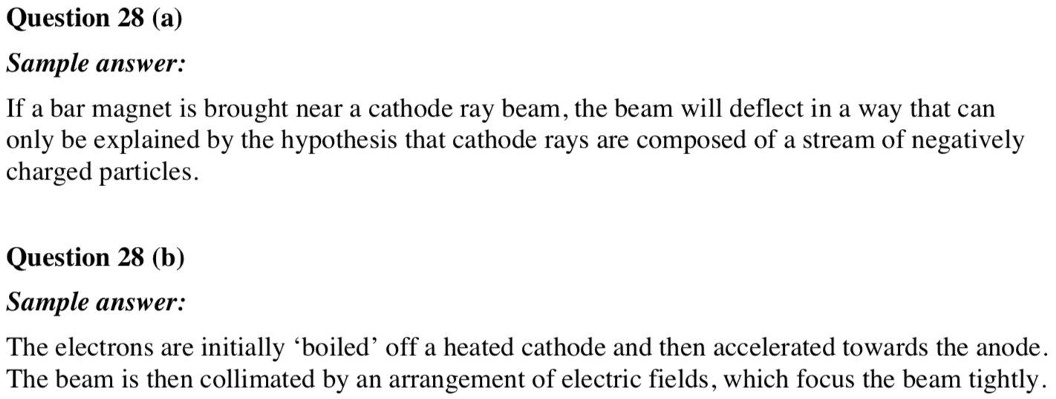

**2010:**

16) A

17) D

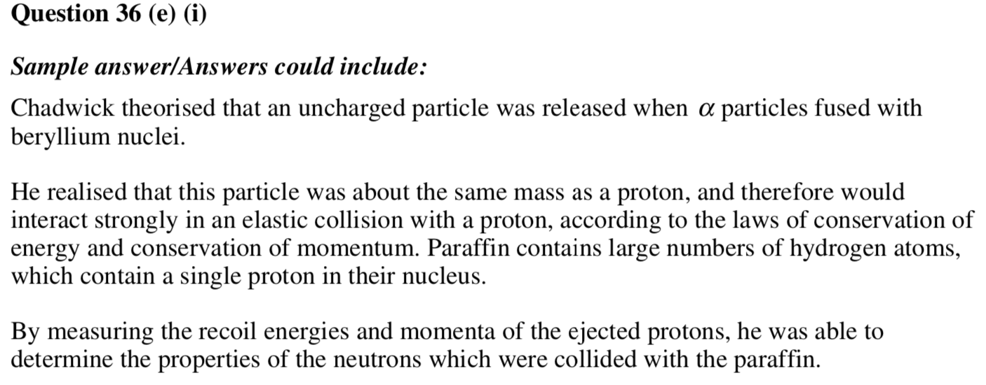

**2009:**

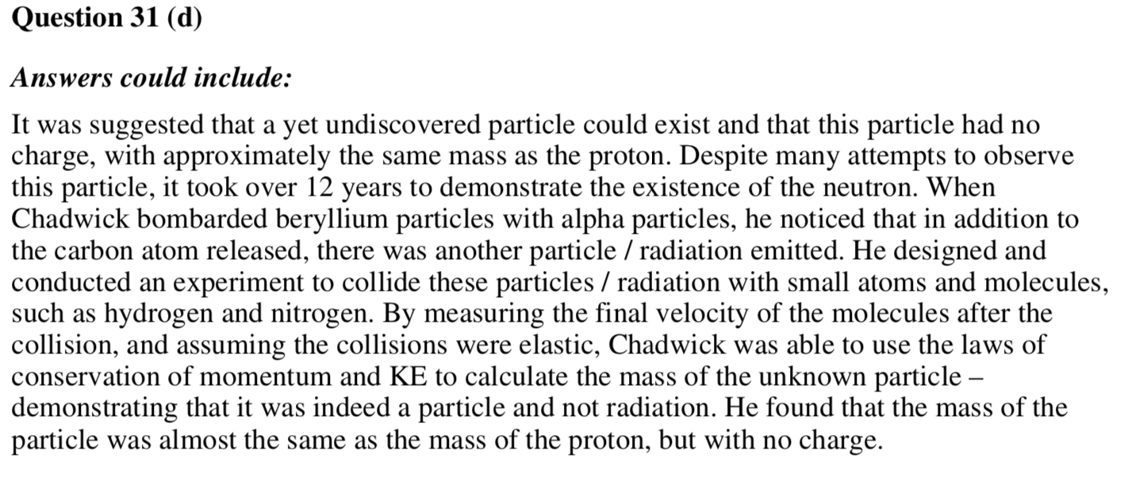

**Before 2009 there were no answers given for short answer please use a book like Excel Physics**